Here’s an example of the LODEsolve function, available for Mathcad 11 and 15 (does not function in any version of Prime):



The above was pasted as ‘Picture (Windows metafile)’ in order to retain the original aspect ratio from Mathcad. It is a single picture and you can resize it at will.

Other paste options are:

* Mathcad document object   
  This also produces a single picture for the total of selected expressions, but it fails to show the results…
* Formatted text (RTF)

Some examples from Spiegel, Murray R., ***Laplace transforms***, Chapter 3,

**Solved problem 1:**











Check:



or:







Messes up the file, and causes do a lot of relocating etc.

* Bitmap  
  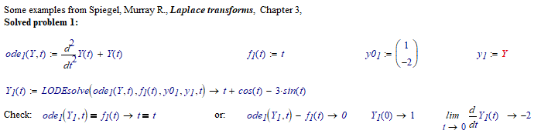This picture paints a thousand words.