Price stream and offsets and revenue calculations
Before moving on to the calculations on the policies we first need to figure out the flow of prices and demands in our system. During the sync db process the price, cost and demand are entered through the following tables
- Price - IPCSDD_PRICE
- Cost - IPCSDD_COST
- Demand - IPCSDD_DEMAND_HISTORY

In servigistics we use the concept of streams. Each demand record comes in with a specific stream. The ids for these can be seen in the IPCS_DEMAND_STREAM. A snapshot of the table is shown below.
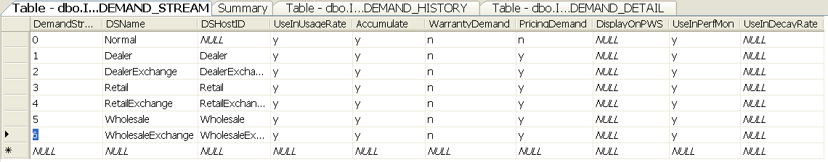

This shows all the demands streams that are available for the customer. This fields are usually entered only once during the implementation of servigistics. However the user can always enter new streams using the IPCSDD_DEMAND_STREAM table. For a stream to be active for pricing we need to have the columns WarrantyDemand=’n’ and PricingDemand=’y’. As can be seen for the table above the streams Dealer, Dealer Exchange, Retail, Retail Exchange, Wholesale, Wholesale Exchange are active. These have specific stream ids attached to them. The demand coming in from the IPCSDD_DEMAND_HISTORY are mapped with the respective streams using the demand stream id. The fields which do not have WarrantyDemand=’n’ and PricingDemand=’y’ are neglected by the pricing solution i.e. ‘Normal’ in the above example.
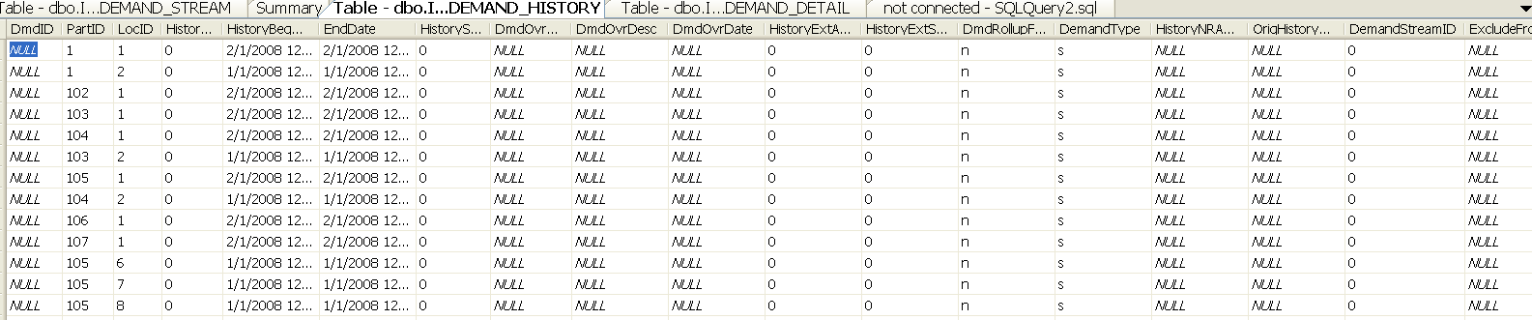
As we can see from the demand history table above there is a specific DemandStreamID for each row of
demand that is added.
Similarly for pricing we have various streams defined for diffefrent demand streams.These are mapped in the table IPCS_PRICING_STREAM as shown below.
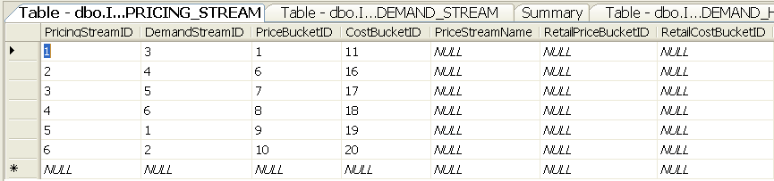
So for demand stream 3 i.e. Retail the pricing stream 1 is assigned. In servigistics we do all the calculations based only upon one pricing stream. For the rest of the streams the price is decided based upon offset calculations which we will get into later.
So each pricing stream is associated with a pricing bucket. This bucket tells what price from the IPCS_PRICE record is used for which stream. To make things more clear I am first showing a IPCS_PRICE record:
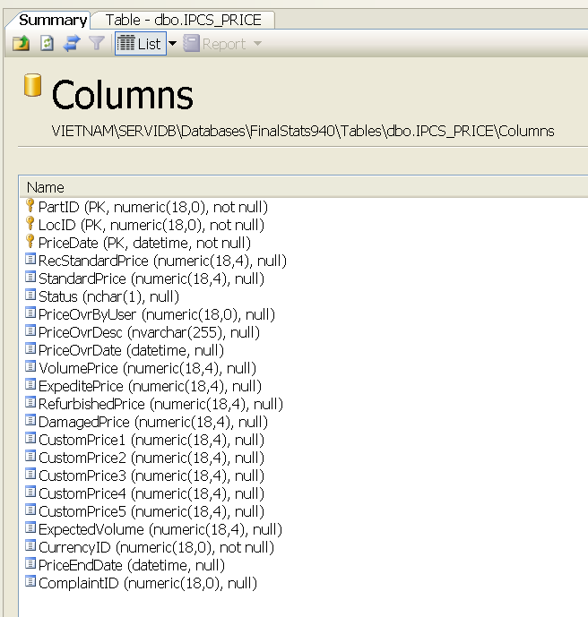
Each price record comes in with many prices defined for the same part/loc pair. So for each pricing stream we define a specific price from the price record. This association is made using the PriceBucketID and CostBucketID from the IPCS_PRICING_STREAM table shown above. Lets follow pricing stream 1 for reference. It is associated with demand stream 3 i.e. ‘Retail’. Now we assign different prices to it using the PriceBucketID column and the CostBucketIDs. These ID’s can be seen from the IPCS_PRICING_BUCKET:
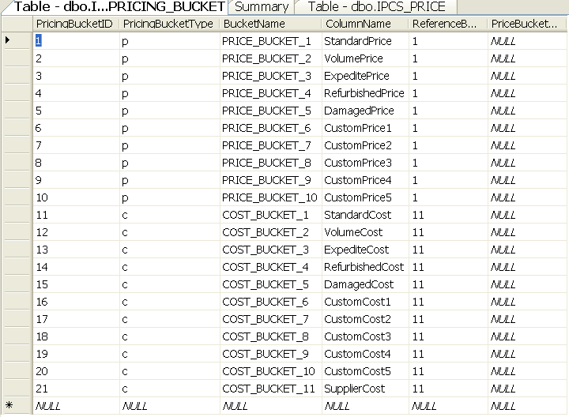
So for the pricing stream 1 we have pricing bucket id=1 i.e. ‘Standard price’ and cost bucket id=11 which is ‘Standard Cost’. Therefore for each IPCS_PRICE the standard price and standard cost are used for calculation of the Pricing stream 1.
Coming back to offsets, all the calculations go on only the main stream. The prices for the other streams are calculated based on certain offsets. These offsets are calculated based upon the latest IPCS_PRICE record for the stream. Illustrating this using an example:
The pricing streams are set up in the following manner as can be seen from the IPCS_PRICING_STREAM table:
1-Retail-Standard Price-Standard Cost
2.-Retail exchange-Custom Price 1-Custom Cost 1
3-Wholesale- Custom Price 2- Custom Cost 2
4-Wholesale exchange- Custom Price 3- Custom Cost 3
5-Dealer- Custom Price 4- Custom Cost 4
6-Dealer exchange- Custom Price 5- Custom Cost 5
Now extracting only the required information from the IPCS_PRICE for partid=3 and locid=1.
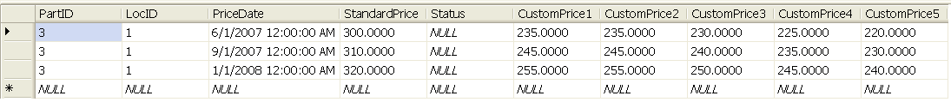
As mentioned above all demand streams from 1 to 6 are valid pricing demand streams.
Offsets to be used in the calculation are found out from the latest record for the part/loc pair in the IPCS_PRICE table. In the above shown table that is the last row. Therefore the offsets should be:
For stream 2: (Custom price 1/Standard price)=255/320 = 0.796875
For stream 3: (Custom price 2/Standard price)=255/320 = 0.796875
For stream 4: (Custom price 3/Standard price)=250/320 = 0.78125
For stream 5: (Custom price 4/Standard price)=245/320 = 0.765625
For stream 6: (Custom price 5/Standard price)=240/320 = 0.75
The offsets for costs are also calculated in the same manner using the latest entry in the IPCS_COST table.
These results are stored in the IPCS_SKU_PRICING_BUCKET table:
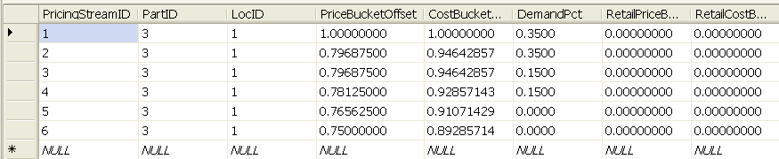

The DemandPct values are calculated from the IPCS_DEMAND_HISTORY tables.
Finally coming to revenue calculation on the policy details page, it is simply the summation of the prices of every stream:
Stream revenue= ((Standard Price*PriceBucketOffset)*(DemandPct*TotalVolume))
Total revenue is calculated by summing up the revenues of every stream.
Similarly
Stream profit = (( Standard Price * PriceBucketOffset - Standard Cost * CostBucketOffset)* DemandPct * TotalVolume ))
Total profit is calculated by summing up the total profit from all the streams.

SQL Query: IPCS_DEMAND_HISTORY
SELECT PartID, LocID, HistoryAmount AS Expr1, DemandStreamID, ExcludeFromPricing
FROM IPCS_DEMAND_HISTORY
WHERE (PartID = 1) AND (LocID = 1) AND (HistoryBegDate >= '1/1/2007 12:00:00 AM') AND (HistoryBegDate < '1/1/2008 12:00:00 AM')

