ODD MEMBERS EDITING BEHAVIOR

- For every object type except Package, the Guest Role is hidden by the related preference
- For Package only, The Guest Role is displayed when editing the Members Table directly

Guest Preference Setting, Ref


From Task from Package Routing Workflow Process – Works As Expected
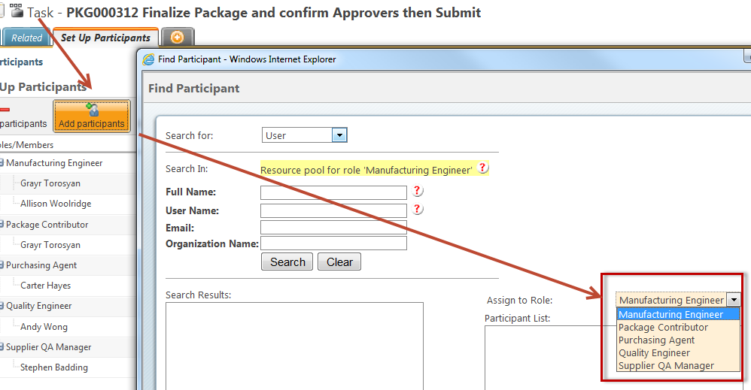

From Object Members Table - Guest Role Displays Unexpectedly
Ref Tech Support case C11998585:
“As per Windchill product design it is not possible to remove ‘Guest’ Role from team. You can file an enchantment request for to get this functionality.”
