This is what I downloaded and extracted – also tried to copy to staging from within the installer

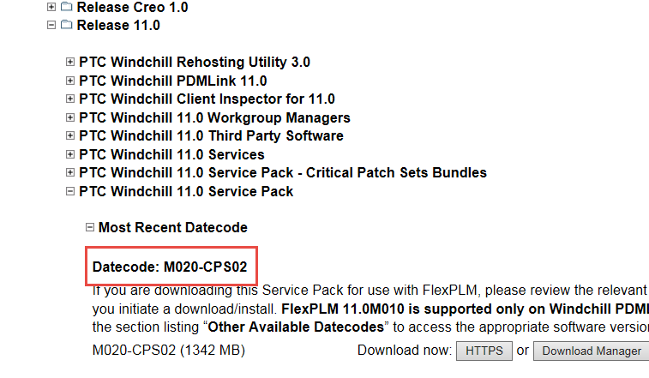

Also downloaded and extracted this

