Simple Query Builder Report on Workflow Process Status

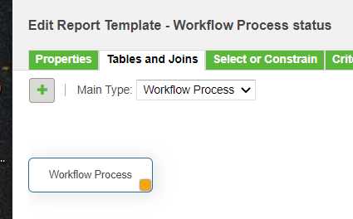

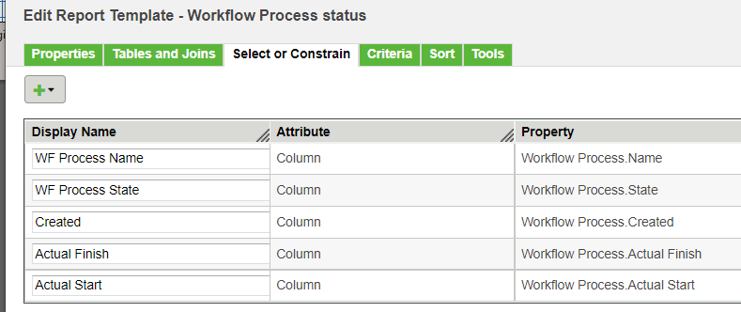

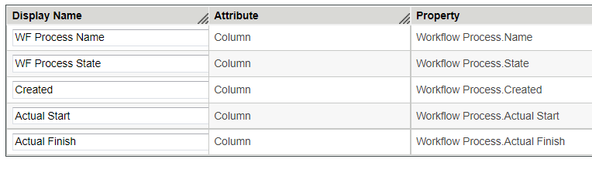
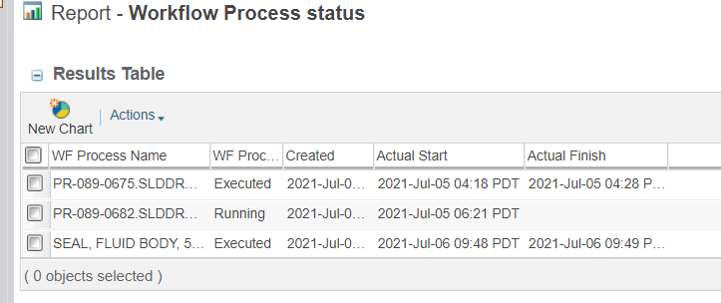

SQL

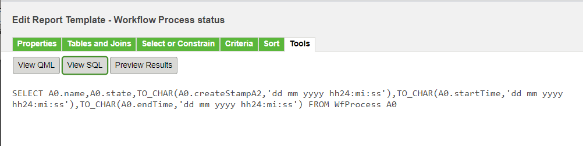

SELECT A0.name,A0.state,TO_CHAR(A0.createStampA2,'dd mm yyyy hh24:mi:ss'),TO_CHAR(A0.startTime,'dd mm yyyy hh24:mi:ss'),TO_CHAR(A0.endTime,'dd mm yyyy hh24:mi:ss') FROM WfProcess A0

Run directly against the database (Oracle in this example) with date criteria handled differently.

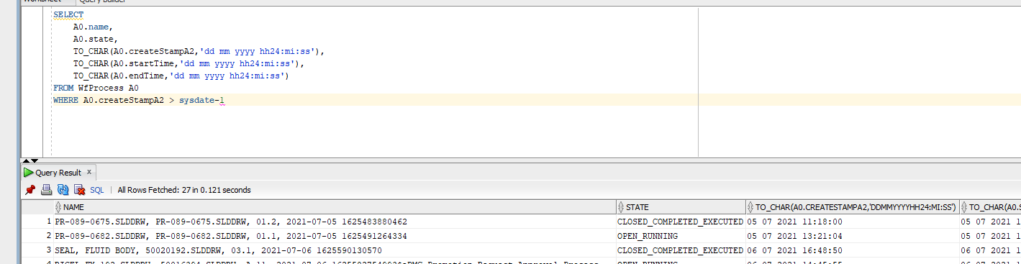

Reference

