Windchill 12.0 Standard Base Installation Procedure
Version: 12.0.0.3

Prerequisite: Install Media – Java (Corretto)

Download from:
Ja va 8
Java 11

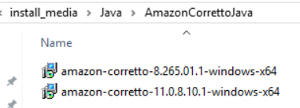

Prerequisite: Install Media - Windchill

Download from
PTC Software Downloads

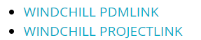

Note: See separate supplemental install documents for additional modules including PartsLink, Index search client & server, etc.

From 12.0 PDMLink:
From 12.0 ProjectLink:
From 11.2 PDMLink – ref CS326880:

Important note: The Critical Patch Sets Bundles zip file needs to be unblocked prior to extracting. Can be done via Properties or command. The other zip files are extracted by the solution installer and do not require unblocking.
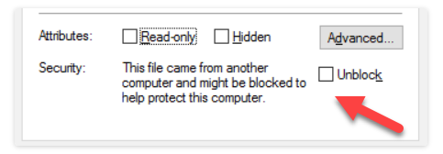

Extract only this zip file (extraction of all other zip files is done by the installer):
Copied to server ready to install
Note: PSI and CPS Bundle folders renamed with underscore to bring to the top (convenience). PSI used only until CPS available.

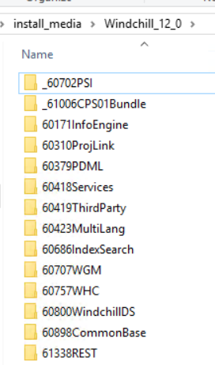

Prerequisite: Install Media – MS Office (Required for Windchill Publishing)

Install only from Software Center, only Word and Excel, 32 bit

Installation – Java

Use Admin command window. Install in the sequence shown.

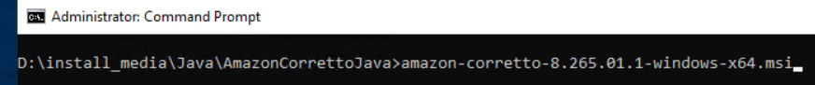

Default path
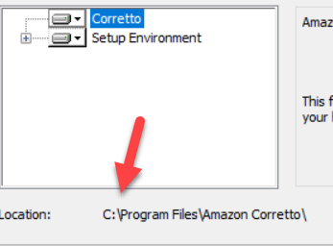

Required path - create needed folders. Must have no spaces in path.

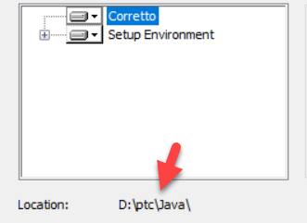

Result

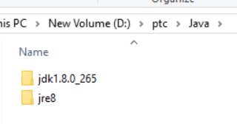
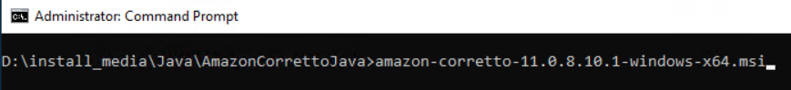

Default path
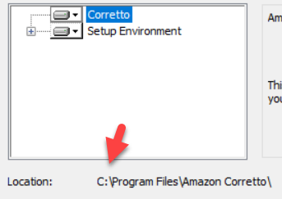

Required path
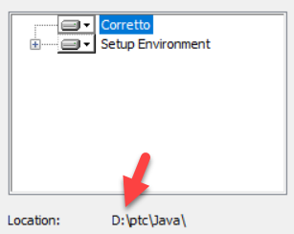

Result
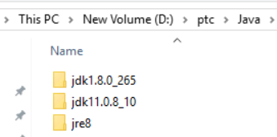

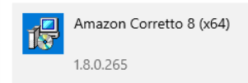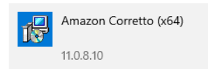

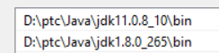

Important: Edit the installed paths as shown and update env variables to match. This allows updating Java for existing Windchill installation without manual edits. Ref CS23639

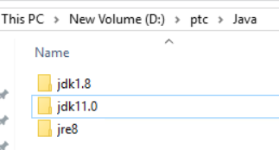

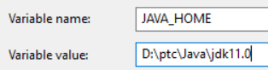

Path env var:

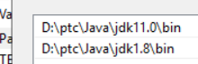

Verify using a new command window by typing java, then set java_home

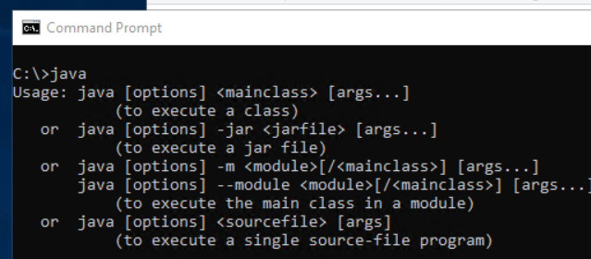

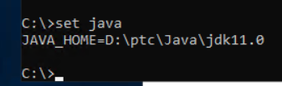

Prerequisite: Oracle database access

Verify that a connection can be created and used in SQL Developer, using the username / password / SID provided by Oracle DBA

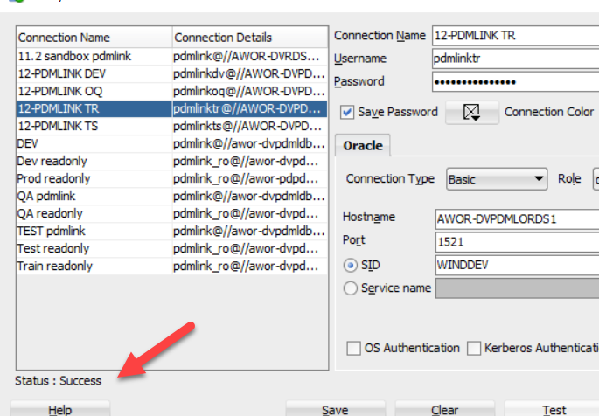

Windchill Installation

Variable | Value - Production | Training | OQ | Test | DV1 | DV2
Web Server DNS Registered Host Name | windchilltobepd.edwards.com | Windchilltr.edwards.com | Windchilloq.edwards.com | Windchillts.edwards.com
Oracle DNS Registered Host Name | awor-pdpdmlords1.am.edwards.com
Global Database Name (SID) or Service Name | windprd | Winddev | Winddev | Winddev | Windev | windev
User Name | pdmlink | Pdmlinktr | Pdmlinkoq | pdmlinkts
LDAP Server DNS Registered Host Name | windchilltobepd.edwards.com
Web Application Context Root | Windchill
Initial Organization Name | Edwards
Organization Internet Domain Name | edwards.com

Admin command window. Launch from solution installer within CPS.
Note: Need to launch a new command window since the Java env variables were changed.

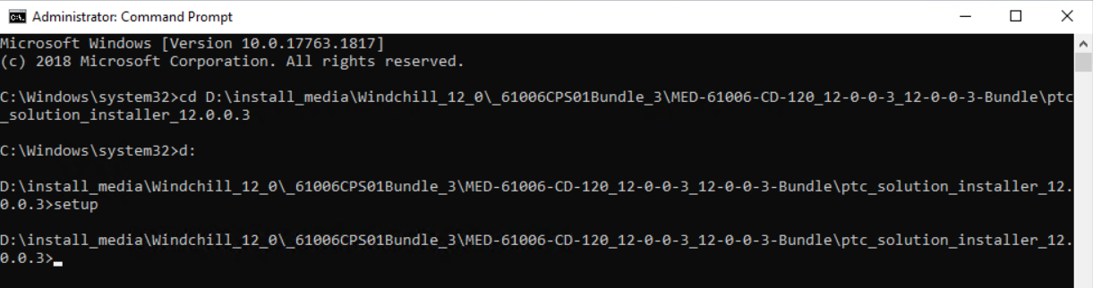

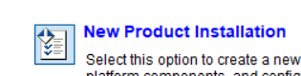

Select only :
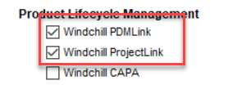

Summary

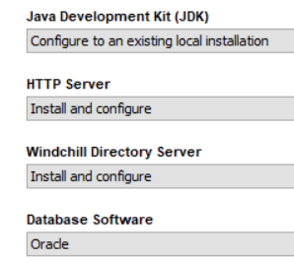
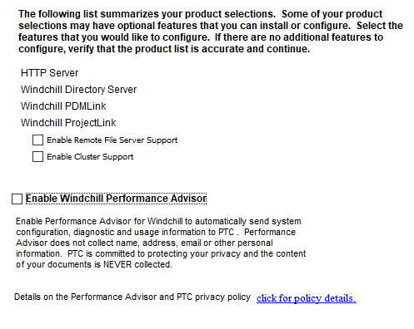
Database and user already need to be created and password provided (prerequisite). Select to Use Existing.

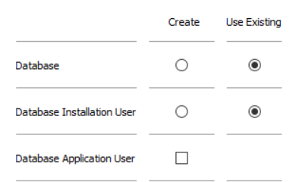

Accept default
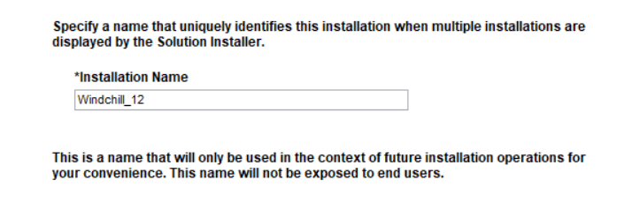
Default path / required path

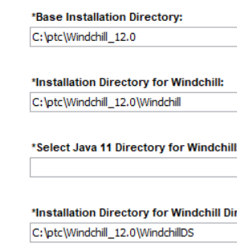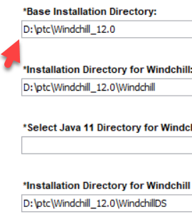

Java paths selected (both 8 and 11 are required)

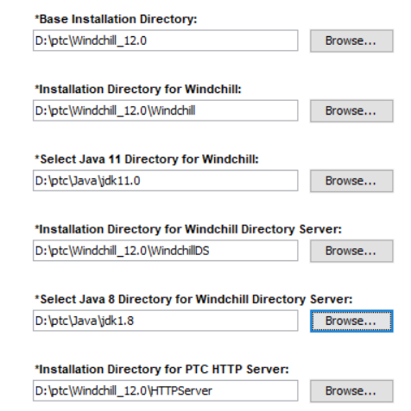

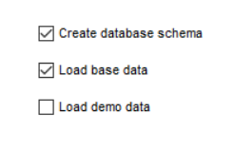
Accept defaults
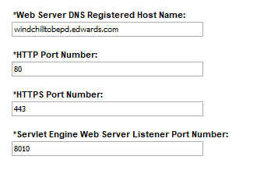
Multi language - Spanish

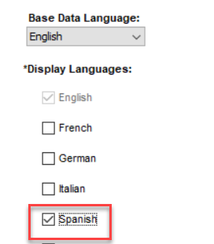

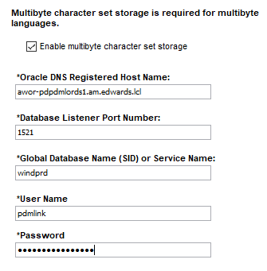
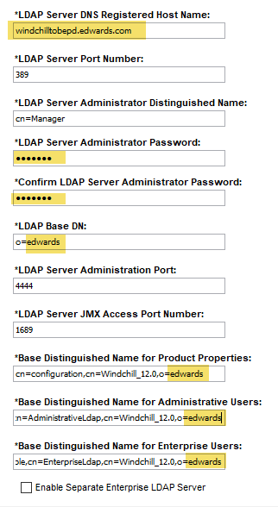

password for now: manager
Replace o=ptc with o=Edwards 4 places
Authorized user needs to obtain license

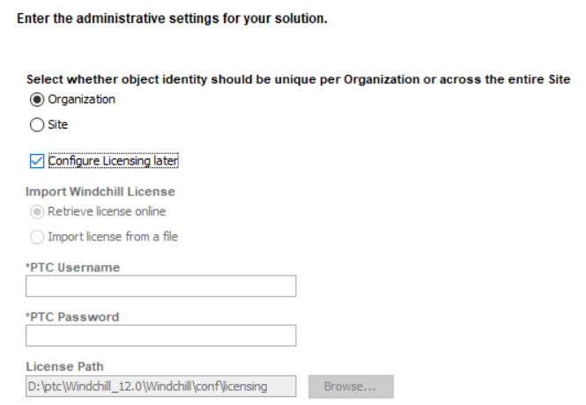

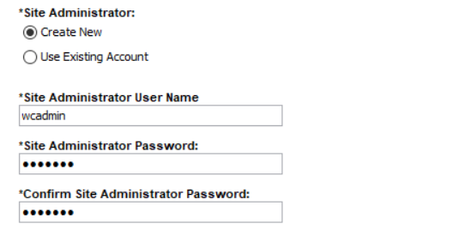

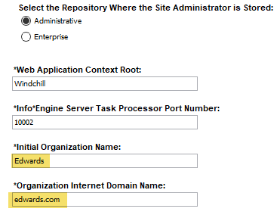

Password for wcadmin now: wcadmin

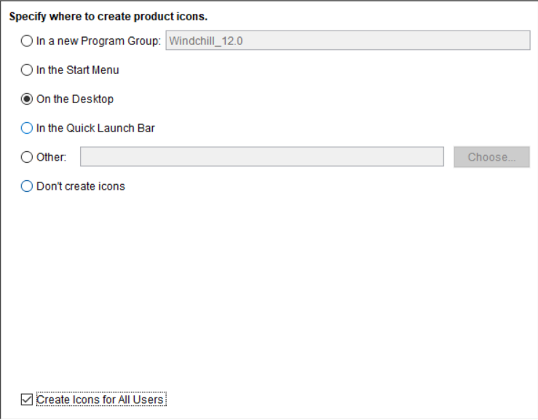

Set staging area here.
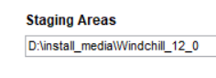
Extract all required install media CDs

Install

Results
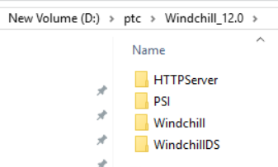
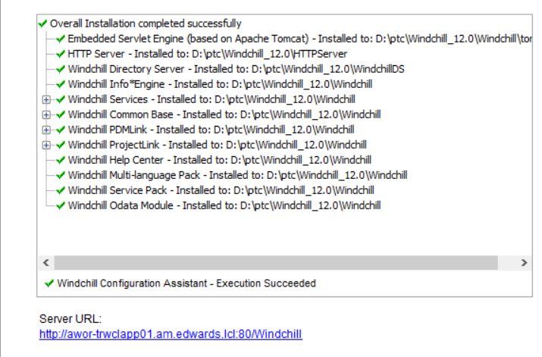

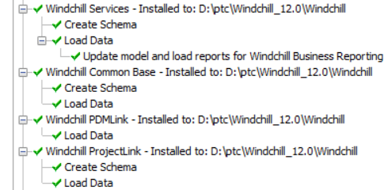

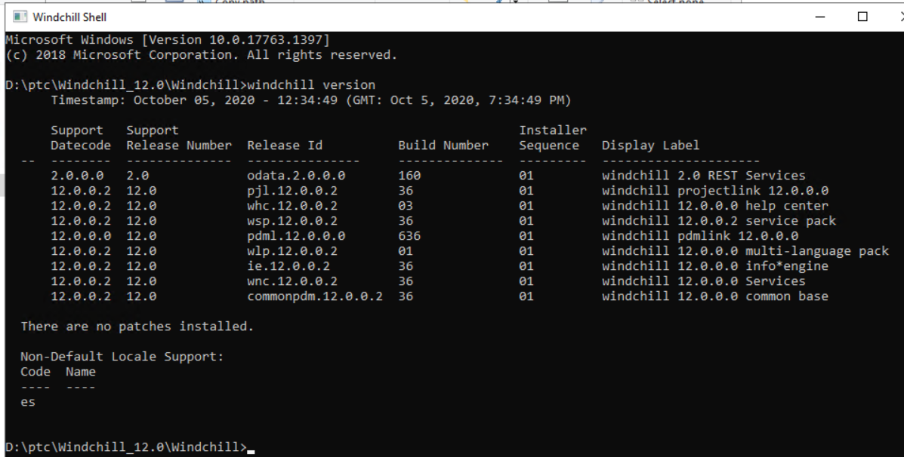

Preserve Initial Installation

Note: This is optional procedure depending on the system that you are working on. E.g. DEV may need frequent backups and restore.

- Export Oracle DMP (request to DBA); name “as installed + <date>” example: as_installed2020Oct05.DMP
- Export ldif; store in location shown; name “as installed + <date>” example: as_installed2020Oct05.ldif
- Copy /ptc folder (except WHC) folder name: Windchill_12.0_as_installed

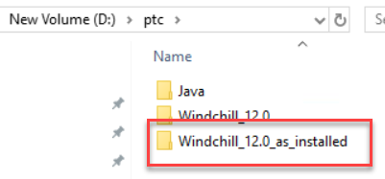

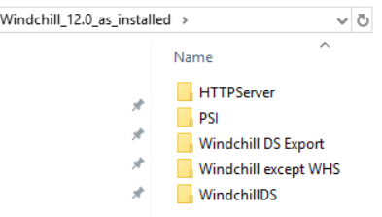

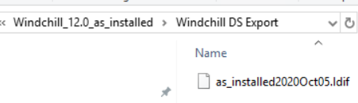

Key Post-Install Actions that Are Considered Part of Base Installation to identify system

Custom banner to identify system
(edit codebase\netmarkets\jsp\util\banner_custom.jspf)

Customize email to identify the server once the email server is connected
(edit Windchill\tasks\wt\mail\SendMail.xml)

APPENDIX: Installation Parameters for Reference

Installation Overview

Installation Name: PTC Installation 1
New Installation
Windchill PDMLink
Windchill ProjectLink
- Windchill Common Base
- Windchill Multi-language Pack
Installing To: D:\ptc\Windchill_12.0\Windchill
Disk Space Required: 6.16 GB

Java Development Kit (JDK)
Configuring to Existing Installation: D:\ptc\Java\jdk11.0

HTTP Server
Installing To: D:\ptc\Windchill_12.0\HTTPServer
Disk Space Required: 146 MB

Windchill Directory Server
Installing To: D:\ptc\Windchill_12.0\WindchillDS
Disk Space Required: 483 MB

Windchill Service Pack
Updating the following products to 12.0 F000-CPS03:
Windchill Info*Engine
Windchill Services
Windchill Common Base
Windchill PDMLink
Windchill ProjectLink
Windchill Multi-language Pack

Base Installation Directory:
D:\ptc\Windchill_12.0\

Shortcut Folder
C:\Users\Public\Desktop

Disk Space Summary of Volume (D:):
Required: 6.82 GB
Available: 125.62 GB

Data Loader Settings

Create database schema
Yes
Load base data
Yes
Load demo data
No

Web Server and Servlet Engine Settings

Web Server DNS Registered Host Name:
windchilltobepd.edwards.com
HTTP Port Number:
80
HTTPS Port Number:
443
Servlet Engine Web Server Listener Port Number:
8010
Servlet Engine DNS Registered Host Name:
localhost

Language Settings

Base Data Language:
English
Display Languages:
Spanish

Database Settings

Multibyte character set storage is required for multibyte languages.
Enable multibyte character set storage
Oracle DNS Registered Host Name:
awor-pdpdmlords1.am.edwards.lcl
Database Listener Port Number:
1521
Global Database Name (SID) or Service Name:
windprd
User Name
pdmlink

LDAP Server Settings

LDAP Server DNS Registered Host Name:
windchilltobepd.edwards.com
LDAP Server Port Number:
389
LDAP Server Administrator Distinguished Name:
cn=Manager
LDAP Base DN:
o=edwards
LDAP Server Administration Port:
4444
LDAP Server JMX Access Port Number:
1689
Base Distinguished Name for Product Properties:
cn=configuration,cn=Windchill_12.0,o=edwards
Base Distinguished Name for Administrative Users:
ou=people,cn=AdministrativeLdap,cn=Windchill_12.0,o=edwards
Base Distinguished Name for Enterprise Users:
ou=people,cn=EnterpriseLdap,cn=Windchill_12.0,o=edwards
Enable Separate Enterprise LDAP Server
No

JNDI Adapter Settings

Enterprise Repository LDAP Server Host Name:
windchilltobepd.edwards.com
Enterprise Repository LDAP Server Port:
389
Enterprise Adapter Name
com.edwards.EnterpriseLdap
LDAP Connection
Bind as User
Enterprise Repository LDAP User Distinguished Name:
cn=Manager
Windchill Privileges for Repository
Read, Write
LDAP Service
Other V3 Compliant LDAP
Repository Contains
Users

Core Product Settings

Select whether object identity should be unique per Organization or across the entire Site
Organization
Site Administrator:
Create New
Configure Licensing later
Configure Licensing later
Import Windchill License
Retrieve license online
Site Administrator User Name
wcadmin
Select the Repository Where the Site Administrator is Stored:
Administrative
Web Application Context Root:
Windchill
Info*Engine Server Task Processor Port Number:
10002
Initial Organization Name:
Edwards
Organization Internet Domain Name:
edwards.com

Windchill Performance Advisor

Enable Windchill Performance Advisor
No

END OF BASE INSTALLATION

