Clearing your java cache

1). Go to your Java Control Panel.

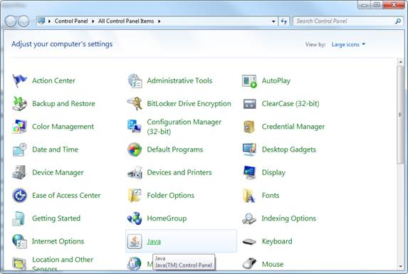

2). Select ‘Temporary Internet Files’.
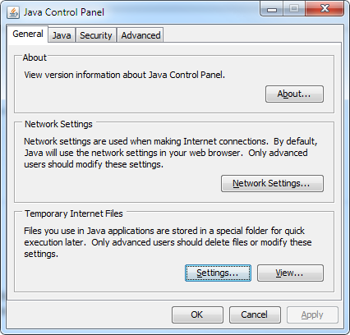

3). Select ‘Delete Files…’.
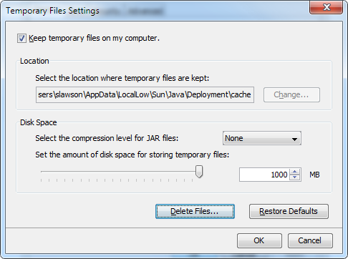

4). Clear Applications and Applets.

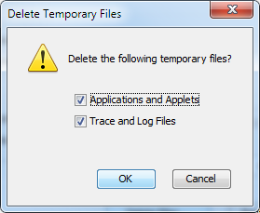

5). Hit ‘OK’.

Windchill should then pick up the latest applet.

