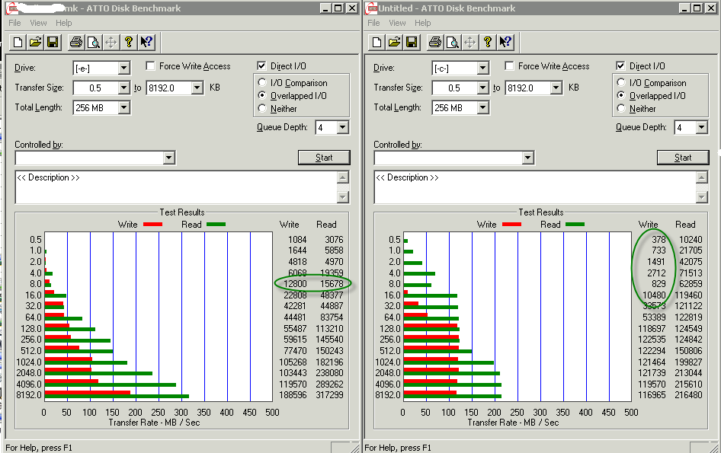
Left is benchmark for Netapp storage Oracle runs data files. Right is local C drive OS and pagefile.
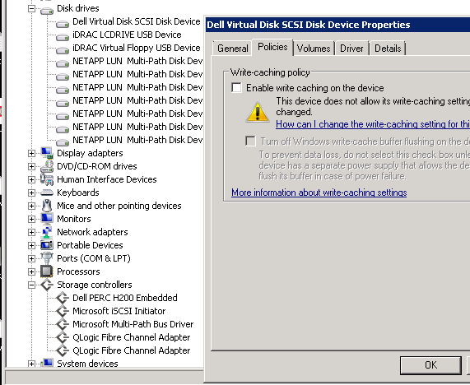
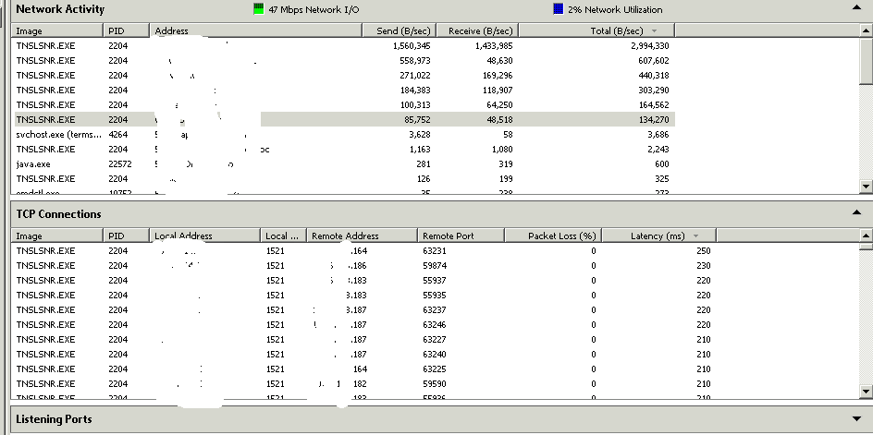
Latency exceeds 200 ms

