WQS Report binder Display Option Change Request

- Here is our current reports and Report binder in Project navigator
- 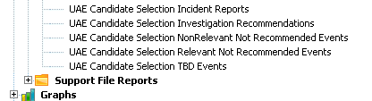
- The top report “UAE Candidate Selection Incident Reports” is the binder report
- The “UAE Candidate Selection Incident Reports” combines the 4 reports underneath it.
- See the Report binder details below:
- 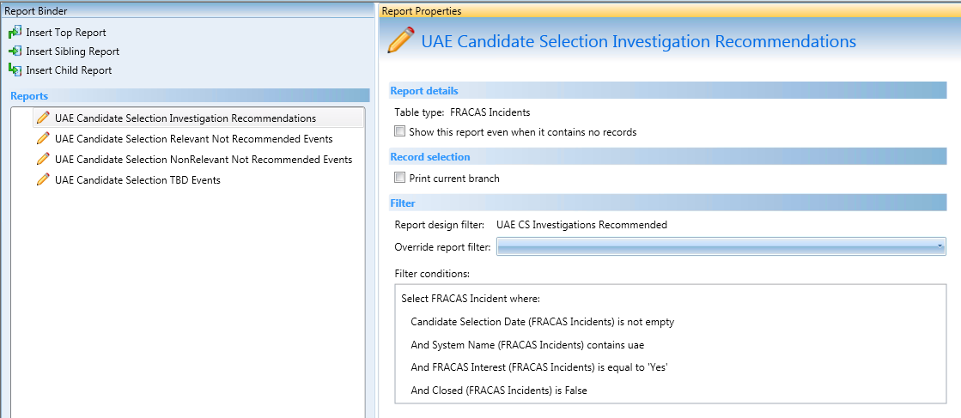
- Users are getting confused when seeing this long list of reports when they only want to run the binder report (UAE Candidate Selection Incident Reports) which in turns runs the other 4 report at once.
- It would be beneficial to have the capability to hide the binder report so that user only would see the binder report and not all of the reports.
- We would like the user to only see the following:
- So I was wonder is there any way to do this in WQS now and if not will this be added in the near future.

