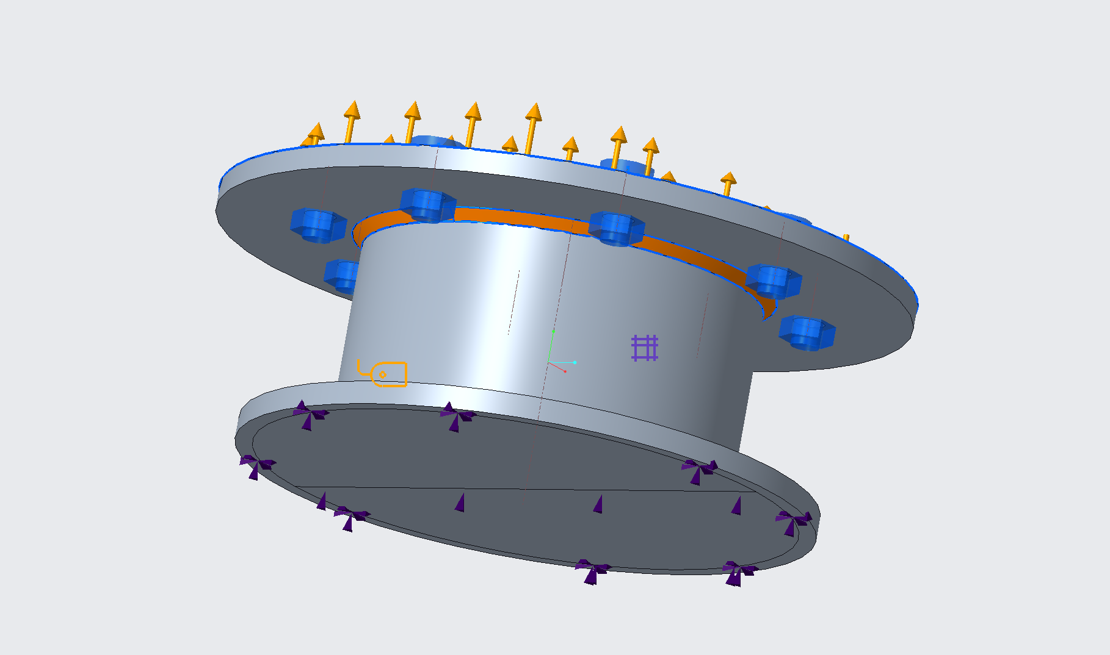

WELD IS DETECTED – SEE BLUE HIGHLIGHT AROUND ORANGE WELD FEATURE

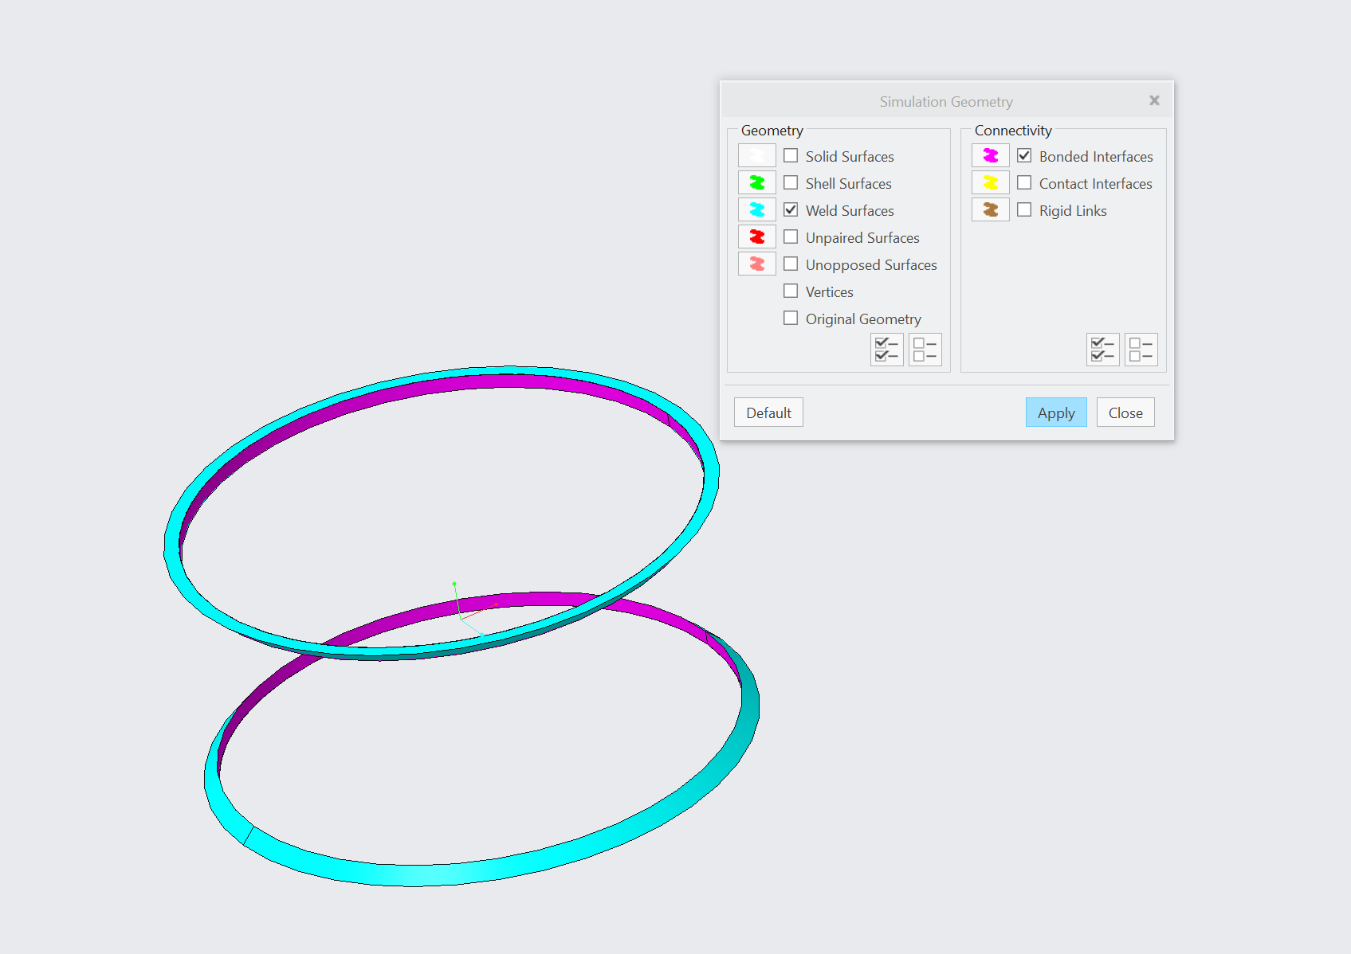

WELD FEATURE TOOL ONLY CREATES BONDED SURFACE ON 1 SIDE OF WELD.

WELD FEATURE SHOULD SHOW PURPLE ON BOTH SURFACES